

Single Equality Policy

Adopted: February 2026

Due for review: February 2029

1. Aims
- Take positive and proactive steps to identify areas of potential inequality before they have the chance to make an impact
- Make changes to ensure that any areas of potential inequality are eliminated
- This policy will underpin all other policies within our school
- This policy should be read in conjunction with our Special Educational Needs and Disability and Anti-bullying policies

Lead Member of Staff: Mrs Sarah McFarlane

2. Background Information
- The Equality Act 2010, which came into force on 1 October 2010, replaces the existing anti-discrimination laws with a single Act, this policy therefore brings together our previous policies on Equal Opportunities, Race, Disability and Gender and now protects children, staff and parent/carers and service users from discrimination, harassment and victimisation based on all Protected Characteristics (Race, Disability, Sex, Religion or belief,
Sexual orientation and Gender reassignment)

- NB: Age is now also a protected characteristic but does not apply to children in schools. It does however still apply to staff and parent/carers.

3. Legal Definitions

Unlawful Discrimination
- Unlawful discrimination is defined in the Act as:

- Direct discrimination – treating a person less favourably on prohibited grounds (gender, gender identity, race, disability, sexual orientation, religion or belief, age, socio-economic status) than another would be treated in comparable circumstances, where the treatment cannot be objectively justified (e.g. by a genuine occupational requirement)

- Indirect discrimination – when a rule, condition or requirement, which applies equally to everyone, has a disproportionately adverse effect on people from a particular group (i.e. due to race, religion or belief, sexual orientation, age, gender, marital status, gender identity), and there is no objective justification for the rule

- Discrimination arising from disability – This occurs when a disabled person is treated unfavourably because of something connected with their disability and this unfavourable treatment cannot be justified. Treatment can be justified if it can be shown that it is intended to meet a legitimate objective in a fair, balanced and reasonable way. If this can be shown then the treatment will be lawful. This may be discrimination arising from disability unless it can be justified.

- Failure to make reasonable adjustments (for disabled people)

- Discrimination by association or perception – the 2010 Act extends the scope of the legislation to protect people who ‘associate’ with others with the protected characteristics, for instance people who are related to or who care for someone who is disabled. Protection includes perception (e.g. discrimination based on the belief that someone is gay, disabled or has a particular belief)

Harassment
- Harassment is defined in the Act as:
- Any unwanted conduct that violates people’s dignity or creates an intimidating, hostile, degrading, humiliating or offensive environment. This definition is limited to anti-discrimination legislation and therefore only applies to harassment on grounds of sex, race, disability, sexual orientation, religion, belief or age.

Victimisation
- Victimisation is defined in the Act as:
- Treating people less favourably because they have made a complaint or intend to make a complaint about discrimination or harassment, or have given evidence or intend to give evidence relating to a complaint about discrimination or harassment.

Burden of Proof
The Act states that once an individual can show that there is an issue of potential discrimination, the burden of proof shifts to the employer to defend the case and show that the reason for difference in treatment is justifiable and not discriminatory.

Vicarious Liability
- The Act states that employers are responsible for the discriminatory actions of their employees where such action have been carried out during the course of their duties. The only defence for employers is to show that they have done everything reasonably practicable to prevent an employee committing an unlawful act.
- In practice, Courts and tribunals have regarded the following as
‘Reasonable steps’
- Publishing a comprehensive equality policy
- Clearly communicating the policy to all staff
- Providing awareness training on the potential for, and implications of, discrimination

- Training staff in good practice relevant to their jobs (e.g. recruitment, record keeping, monitoring etc)

Personal Liability
- The act states that where an employer can show that appropriate steps have been taken to avoid discrimination, it is likely that the discriminator will be personally liable in the law.
- Single Equality Duty
- The 2010 Act introduces a new ‘single’ equality duty which brings together the three existing duties (race, disability and gender) and extends the duty to gender reassignment, age, sexual orientation and religion or belief. This new duty requires all public bodies to have ‘due regard’ to the need to:
- Eliminate discrimination, harassment, victimization and any other conduct that is prohibited
- Advance equality of opportunity between persons who share a relevant ‘protected characteristic’ and persons who do not share it
- Foster good relations between persons who share a relevant ‘protected characteristic’ and persons who do not share it

Single Equality Action Plan
This document brings together all planned actions for meeting and implementing statutory duties in relation to race, disability, gender, sexual orientation and community cohesion and therefore includes our priorities and actions to eliminate discrimination and harassment in those areas. It will be reviewed every three years.

Disability
This section should be read in conjunction with the School’s Special
Educational Needs and Disability Policy

Definition of Disability
- The 2010 Act abandons the previous list of capacities and defines a disabled person as someone who has ‘a physical or mental impairment which has a substantial or long-term adverse effect on his or her ability to carry out normal day-to-day activities’.
- The Act allows disabled pupils to be treated more favourably than nondisabled pupils and, in some cases, requires this to be done, by making reasonable adjustments to put pupils on a level footing with those without a disability

4. Vision and Principles
At Chapelhill Primary, we are committed to ensuring equality of education and opportunity for all children, staff and parent/ carers receiving services from the school, irrespective of:

- Gender
- Sexual orientation
- Race, colour, ethnic or national origins, faith, religion or those who need support to learn English as an additional language
- Disability/health/medical or special educational needs
- Age
- Attainment including those who are gifted and talented
- Socio-economic background
- Being in public care
- Attendance concerns
- Risk of disaffection or exclusion
- Vulnerability
- Changing school’s frequently

We aim to develop a culture of inclusion and diversity in which all those connected to the school feel proud of their identity and able to participate fully in school life. We believe that all pupils should have equal access to opportunities regardless of ability, age, gender, sexual orientation, disabilities, racial or ethnic group. The achievement of all children will be monitored and we will use this data to support children, raise standards and ensure inclusive teaching and learning. We will tackle discrimination by the positive promotion of equality, challenging bullying and stereotypes and creating an environment which champions respect for all. At Chapelhill, we believe that diversity is a strength which should be respected and celebrated by all those who learn, teach and visit here.
- In our school, the teaching and learning, achievements, attitudes and well-being of every child are important. We follow the necessary regulations to ensure that we take the experiences and needs of all our children into account when planning for teaching, learning and pastoral support. At Chapelhill, we do not take educational inclusion and equality for granted. We constantly identify those children who may be missing out, difficult to engage, or feeling in some way to be apart from what we seek to provide. This practice also allows us to promote tolerance and understanding in a diverse society. This approach can only add to the school’s overall aim of raising standards.

5. Objectives
Objective 1
Narrow any gaps in attainment between different groups of children (including gender, ethnicity, disadvantaged, SEND and EAL)
Action: Monitor and analyse pupil progress and attainment by gender, ethnicity, disadvantaged, SEND and EAL
Objective 2
Analyse attendance data of key groups of pupils (including gender, ethnicity, disadvantaged, SEND and EAL) to ensure any barriers to good attendance are identified and addressed
Action: Regularly monitor the attendance of key groups of pupils (including gender, ethnicity, disadvantaged, SEND and EAL)

Objective 3
Promote positive images and attitudes towards those with protected characteristics – focus across all 9 areas and other groups (age, disability, race, gender reassignment, marriage/civil partnership, pregnancy/maternity, religion/belief, sex, sexual orientation and health needs/ mental health
Action: Continue to promote positive attitudes through selecting class texts and independent reading books throughout school by reviewing current stock of texts used in the library against the protected characteristics.
Ensure a range of books and resources are available for assemblies and key themes across the year (e.g. Black History Month, International Women’s Day, World Autism Day etc)
Liaise with subject leaders to monitor inclusion and evidence of diversity strands throughout wider curriculum planning.

Objective 4.
Respond to racist, homophobic, sexual and bullying incidents. Analyse information in order to identify any patterns. Take immediate action where necessary; following school behavior policy.
Analysis of information to ensure patterns in behavior are not repeated. Ensure parents are contacted and are satisfied with the school’s actions. Report incidents in the Headteachers report to governors.

6. Roles and Responsibilities
- Promoting equality and raising the achievement of all children is the responsibility of the whole school. This policy outlines the roles and responsibilities of everyone involved and connected with the school so that everyone knows what is expected of them.

The Role of Governors
- The Local Governing Body has set out its commitment to equal opportunities and it will continue to do all it can to ensure that the school is fully inclusive to children, and responsive to their needs based on race, gender and disability
- The Local Governing Body seeks to ensure that people are not discriminated against when applying for jobs at our school.
- The Governors take all reasonable steps to ensure that the school’s environment gives access to people with disabilities, and also strive to make school communications as inclusive as possible for parents/carers and children
- The Governors welcome all applications to join the school.
- The Local Governing Body ensures that no child is discriminated against whilst in our school.

The Role of the Headteacher
• It is the Headteacher’s role to implement the school’s Equality Plan and is supported by the Local Governing Body in doing so
- It is the Headteacher’s role to ensure that all staff are aware of the Equality Policy, and that staff apply these guidelines fairly in all situations
- The Headteacher ensures that all recruitment selection panels give due regard to this policy, so that no-one is discriminated against when it comes to employment or training opportunities
- The Headteacher promotes the principle of equal opportunity when developing the curriculum, and promotes respect for other people and equal opportunities to participate in all aspects of school life
- The Headteacher treats all incidents of unfair treatment and any incidents of bullying or discrimination, including racist incidents, with due seriousness

The Role of all Staff: Teaching and Associate
- All staff will ensure that all children are treated fairly, equally and with respect, and will maintain awareness of the School’s Equality Policy and Plan
- All staff will strive to provide material that gives positive images and challenges stereotypical images
- All staff will challenge any incidents of discrimination, bullying, prejudice, racism or homophobia, and record any serious incidents, drawing them to the attention of the lead member of staff or Headteacher and record such incidents
- Design and deliver an inclusive curriculum

The role of children
Children will contribute to the development of the Equality Policy and Plan and be made aware how it applies to them. They will be encouraged to treat each other with respect and to report discriminatory incidents

The Role of Parents/Carers
- Take an active part in identifying barriers for the school community and informing the leadership team of actions that can be taken to eradicate these

Strategies to implement our Vision:
- Teaching and learning
- Ensuring all learners have equal access to a rich, broad, balanced, inclusive and relevant curriculum that allows for a range of different learning styles
- Use contextual data to improve the ways in which we provide support to individuals and groups of children
- Monitor achievement data by gender, ethnicity, special educational needs, disability, Free School Meals etc. and action any gaps
- Take account of the achievement of all children when planning for future learning, Pupil Premium and setting challenging targets
- Ensure all children take a full and active role in school life, including the full range of extra-curricular activities in order to prepare them for life in a diverse society
- Use materials that reflect the diversity of the school’s population and local community in terms of race, gender and disability, without stereotyping
- Promote attitudes and values that will challenge racist and other discriminatory behaviour or prejudice and promote the principles of fairness and justice for all
- Seek to involve all parent/carers in supporting their child’s education
- Have high expectations of all the school community and help them fulfil their aspirations
- Provide opportunities for children to appreciate their own culture and celebrate the diversity of other cultures
- Recognise and value bilingualism
- Encouraging classroom and staffroom discussion of equality issues which reflect on social stereotypes, expectations and the impact on learning;
- Including teaching and classroom-based approaches appropriate for the whole school population, which are inclusive and reflective of our pupils

Training
The school supports inclusive practice by ensuring equality is an ongoing focus for staff and governor training

Admissions and Exclusions
- Our admissions arrangements are fair and transparent, and do not discriminate
- Suspensions/Exclusions will always be based on the school’s Relationships and Behaviour Policy. We will closely monitor suspensions/Exclusions to avoid any potential adverse impact and ensure any discrepancies are identified and dealt with

Equal Opportunities for Staff
- We ensure that all recruitment, employment, promotion and training systems are fair to all, and provide opportunities for everyone to achieve
- We are committed to the implementation of equal opportunities principles and the monitoring and active promotion of equality in all aspects of staffing and employment
- All staff appointments and promotions are made on the basis of merit and ability and in compliance with the Law. However we are concerned to ensure wherever possible that the staffing of the school reflects the diversity of our community
- Equality aspects are considered when appointing staff and particularly when allocating Leadership Responsibilities or re-evaluating staff structures, to ensure decisions are free of discrimination

8. Tackling Discrimination
- All staff are expected to deal with any discriminatory incidents that may occur. They are expected to know how to identify and challenge prejudice and stereotyping; and to support the full range of diverse needs according to a child’s individual circumstances
- Incidents of discrimination, harassment or bullying are dealt with by the member of staff present, escalating to a class teacher or member of Leadership Team as required
- All racist incidents are reported to the Deputy Headteacher who reports them to the Local Governing Body on a termly basis. (A racist incident is defined by the Stephen Lawrence Inquiry Report (1999) as: ‘any incident which is perceived to be racist by the victim or any other person’)

Types of Incidents
Types of discriminatory, harassment or bullying incidents that can occur are:
- Physical assault against a person or group because of their colour, ethnicity, nationality, disability, sexual orientation or gender etc
- Use of derogatory names, insults and jokes
- Racist, sexist, homophobic or discriminatory graffiti
- Provocative behaviour such as wearing racist, sexist, homophobic or discriminatory badges or insignia
- Bringing discriminatory material into the school
- Verbal abuse and threats
- Incitement of others to discriminate or bully due to victim’s race, disability, gender or sexual orientation etc
- Discriminatory comments in the course of discussion
- Attempts to recruit others to discriminatory organisations and groups
- Ridicule of an individual for difference e.g. food, music, religion, dress etc
- Refusal to co-operate with other people on grounds of race, gender, disability, sexual orientation etc

This list is non-exhaustive.

Responding to and Reporting Discriminatory Incidents

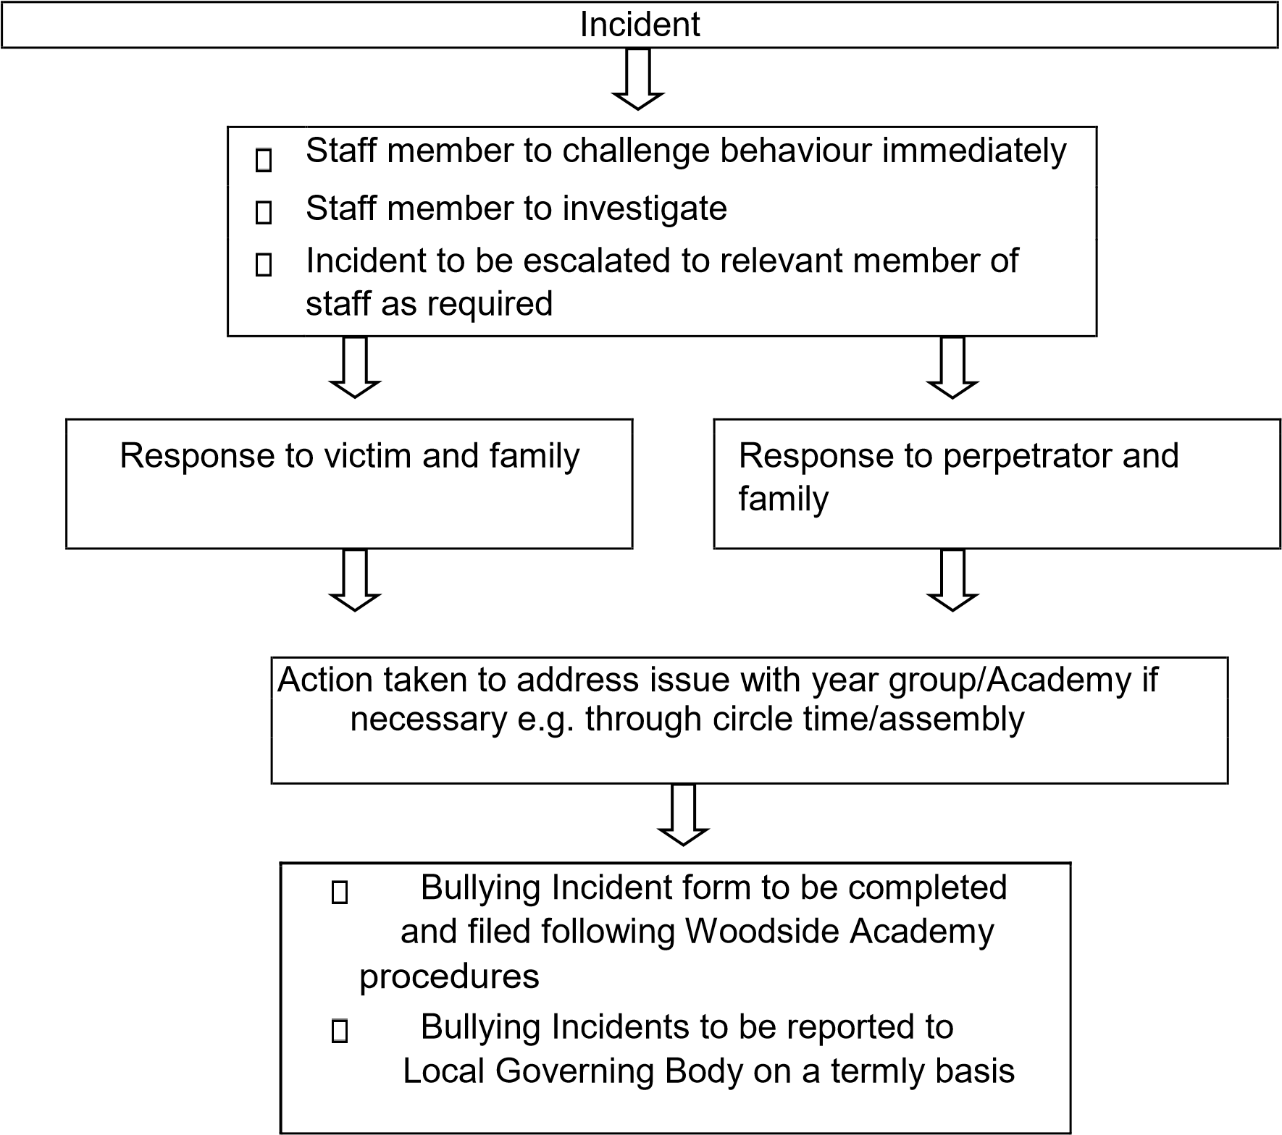

9. Monitoring

The school’s pupil tracking system will be used to track the progress and attainment of children and groups of children to obtain information on whether our equality policy and practice is effective. It is the responsibility of our Local Governing Body to monitor the effectiveness of this Equal Opportunities policy. The Local Governing Body can do this by:
- monitoring the progress of children of minority groups and comparing it to the progress made by other children in the school
- monitoring the staff appointment process, so that no-one applying for a post at this school is discriminated against
- monitoring the school behaviour and exclusions policy, so those children from minority groups are not unfairly treated
- taking into serious consideration any complaints regarding equal opportunity issues from parent/carers, staff or children

10. Monitoring and Evaluation
Staff and Governors, on a three yearly basis, will review this policy unless circumstances demand an earlier review.

